100727 How to copy new FM PO layouts to stores

Tuesday, 27 July 2010

11:43 AM

Note : Update all “ FM “ references (below) to : “ FMT “

The layout is FMT, currently in VIC, you can use the copypo.sh script to copy both the FMT and FM layouts into the dataset.

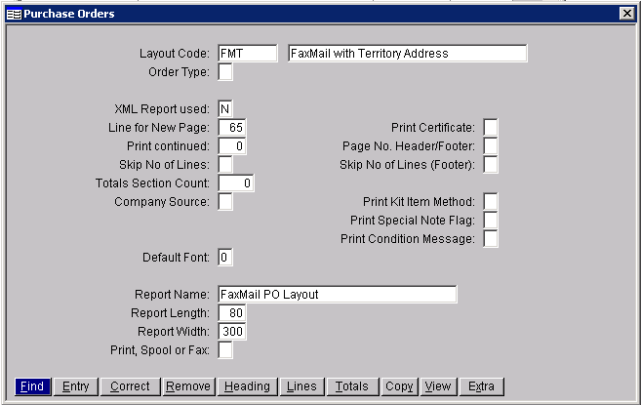

You need to add a PR entry : PO_HRT_H1 ( pointing to) : pvi-snz/pgmovr/po_prt_h1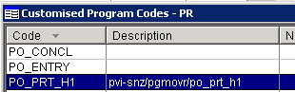

And change POPRINT override from FM to FMT



  
  
  